**New Dashboard(amazom):**

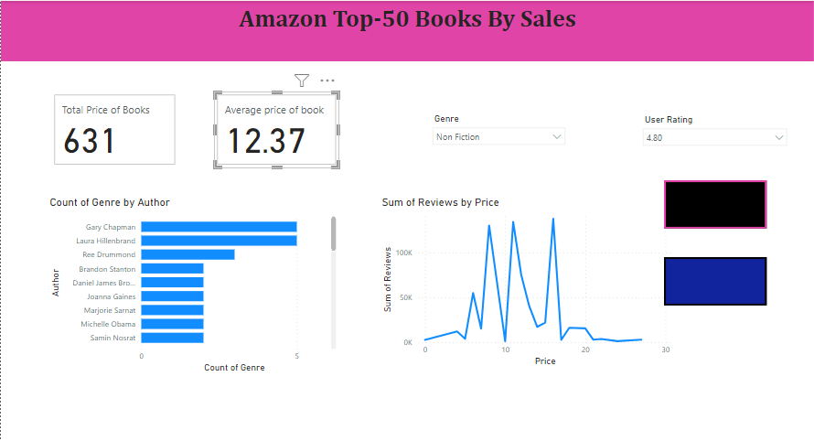**Without Bookmark:**

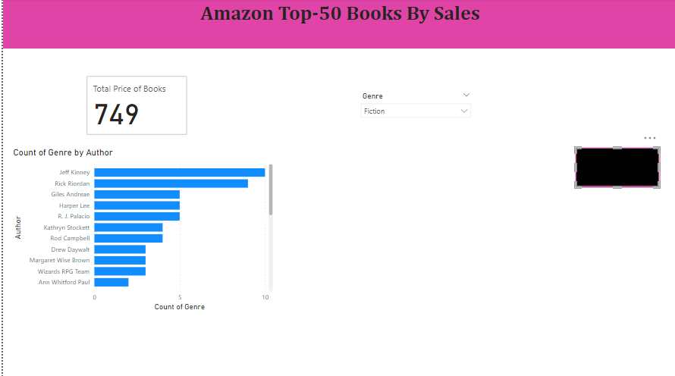**Bookmark 1:**

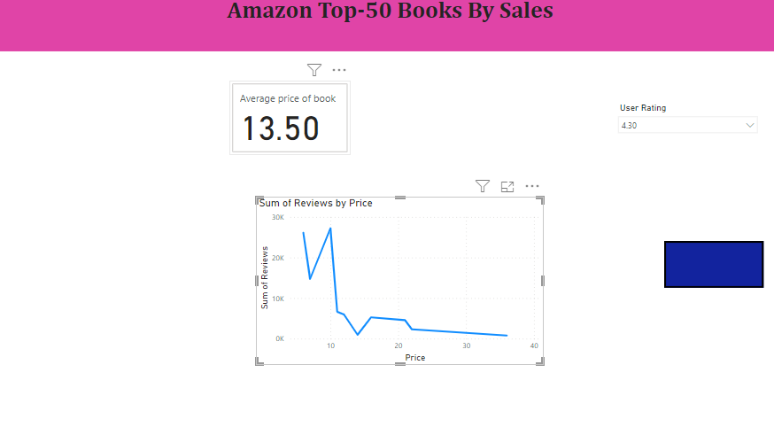**Bookmark 2:**